Fractions worksheet for Week 8
1. | 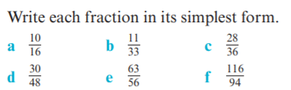
2. | Larni scored 22 of her team’s 34 goals. What fraction of the team’s goals did Larni score? Write your answer in simplest form.
3. | Cristiano spent 75 minutes of a 90-minute football game on the field. What fraction of time, in simplest form, did he spend off the field?
4. | Write four equivalent fractions for $\frac{4}{7}$.
5. | 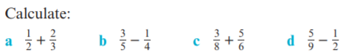

Fractions worksheet for Week 8
1.
2. | Larni scored 22 of her team’s 34 goals. What fraction of the team’s goals did Larni score? Write your answer in simplest form.
3. | Cristiano spent 75 minutes of a 90-minute football game on the field. What fraction of time, in simplest form, did he spend off the field?
4. | Write four equivalent fractions for $\frac{4}{7}$.
5.

